**PG-DAC SEPT 2022**

**Assignment No:1**

**Q.1 Check if the given number is Even or Odd.**

1. Enter a number

2. Divide number by 2, if we get reminder zero it is Even number else it is Odd.

3. Print the result

if **num**% = = 0

**num** is even

Start

Stop

Enter the number, **num**

**num** is odd

True

False

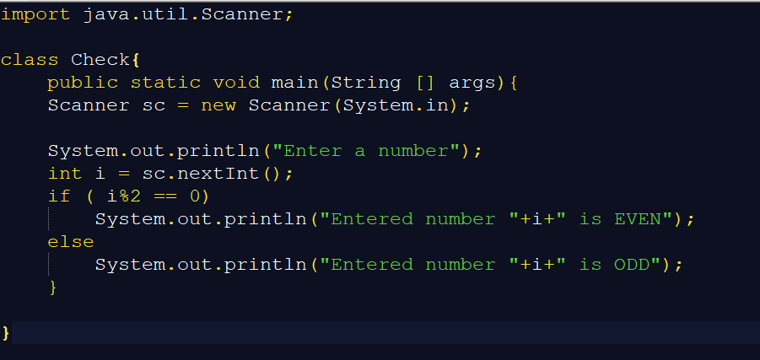

**Q.2 To find factorial of given number**

1. Enter a number

2. Take int i=1, multiply i with int fact until i becomes equal to number.

3. Print value stored in fact.

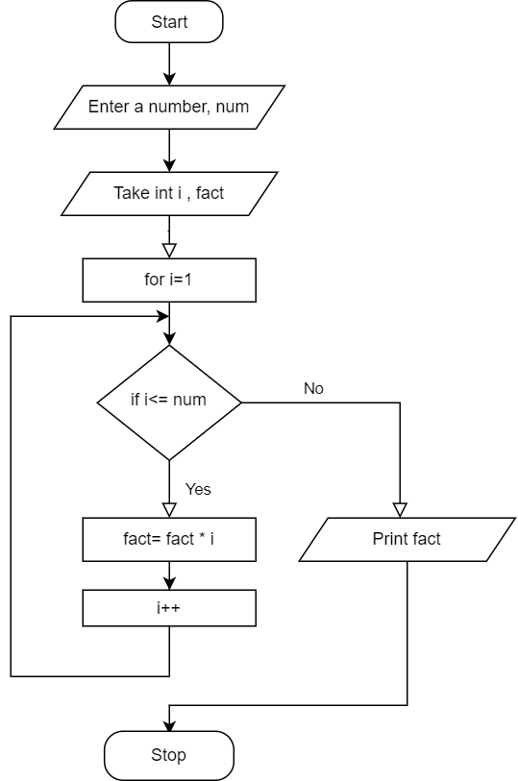

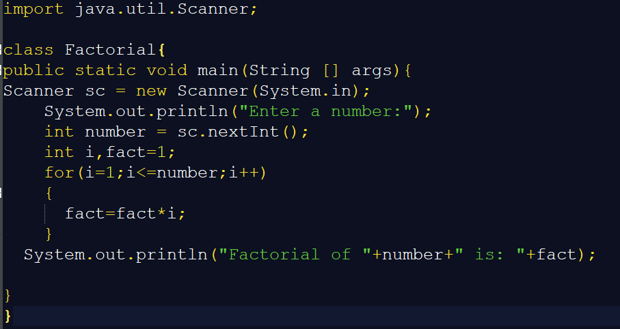

**Q.4 Swap two numbers without using third variable approach.**

For example: a=3, b=2

a = a + b = 3 + 2 = 5

b = a - b = 5 – 2 = 3

a = a - b = 5 – 3 = 2

1. Enter two numbers a and b.

2. Add a and b, store in a.

3. Subtract b from a, store in b.

4. Subtract b from a again and store value in a.

5. Print value of a and b after swap.

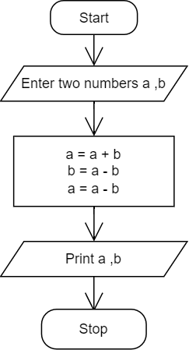

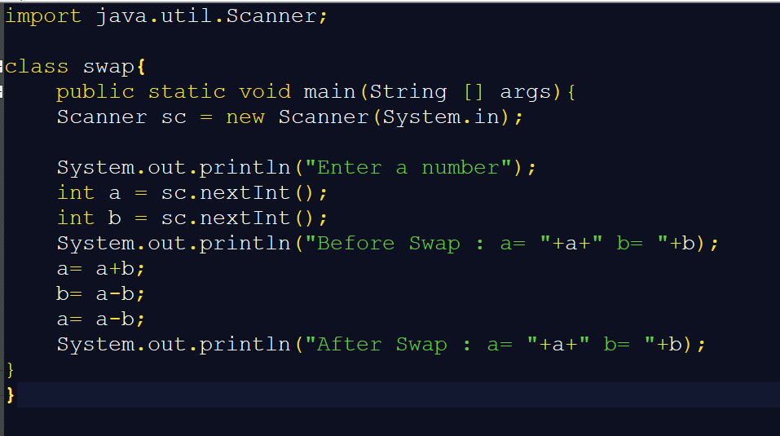

**Q.8 To print digits of a given number.**

1. Enter a number

2. Take int d1, d2, d3, d4.

3. Calculate reminder of number dividing by 10, using %. Store value in d1.

4. Divide number by 10 and calculate reminder of number dividing by 10, using %. Store value in d2.

5. Repeat this Procedure again for d3, d4.

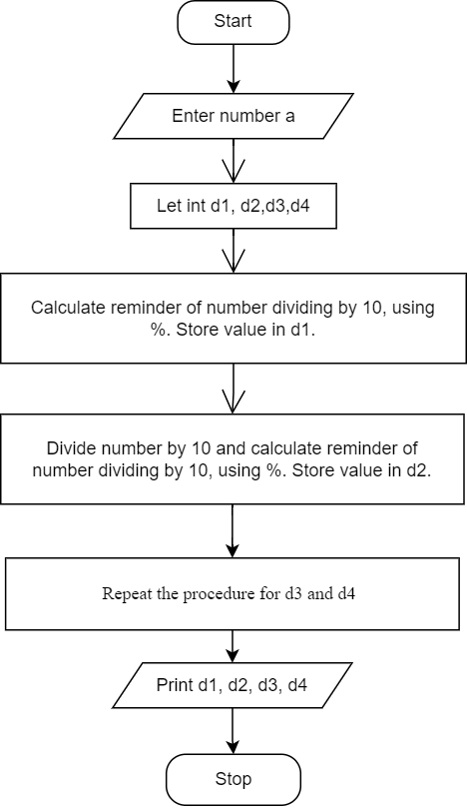6. Print d1, d2, d3, d4.

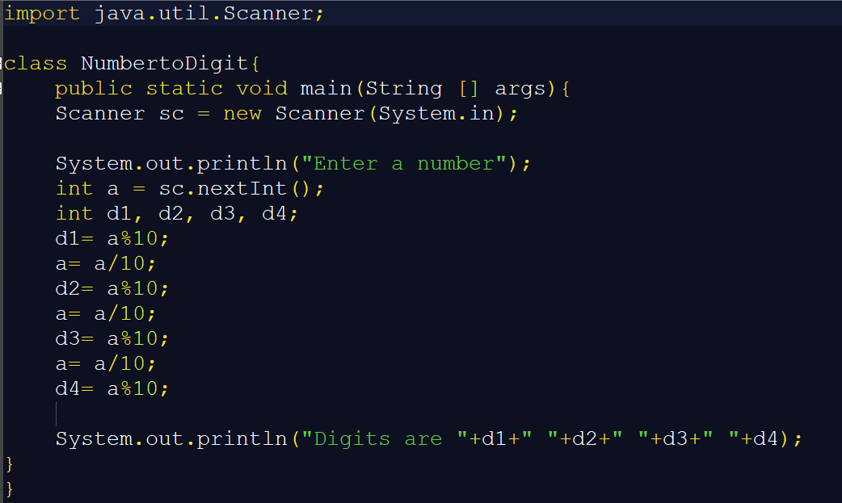

**Q.10 To find sum of the digits of given numbers**

1. Enter a number

2. Take int d1, d2, d3, d4.

3. Calculate reminder of number dividing by 10, using %. Store value in d1.

4. Divide number by 10 and calculate reminder of number dividing by 10, using %. Store value in d2.

5. Repeat this Procedure again for d3, d4.

6. Add d1, d2, d3, d4, store in sum.

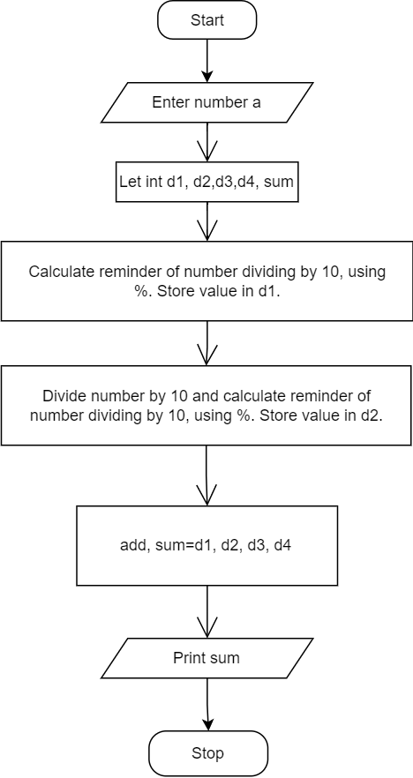7. Print sum.

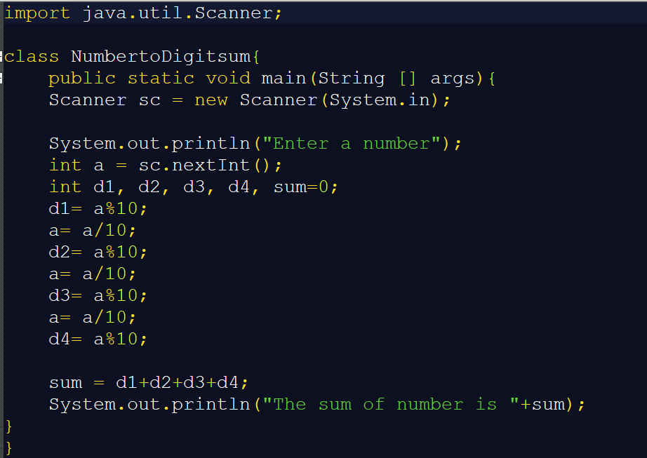

**Q.6 Check whether the given number is leap year or not.**

1. Enter a year.

2. Check if year gets divided by 400, then it is a leap year.

3. If not, check it is divisible by 4 but not by 100.

4. If yes, it is a leap year.

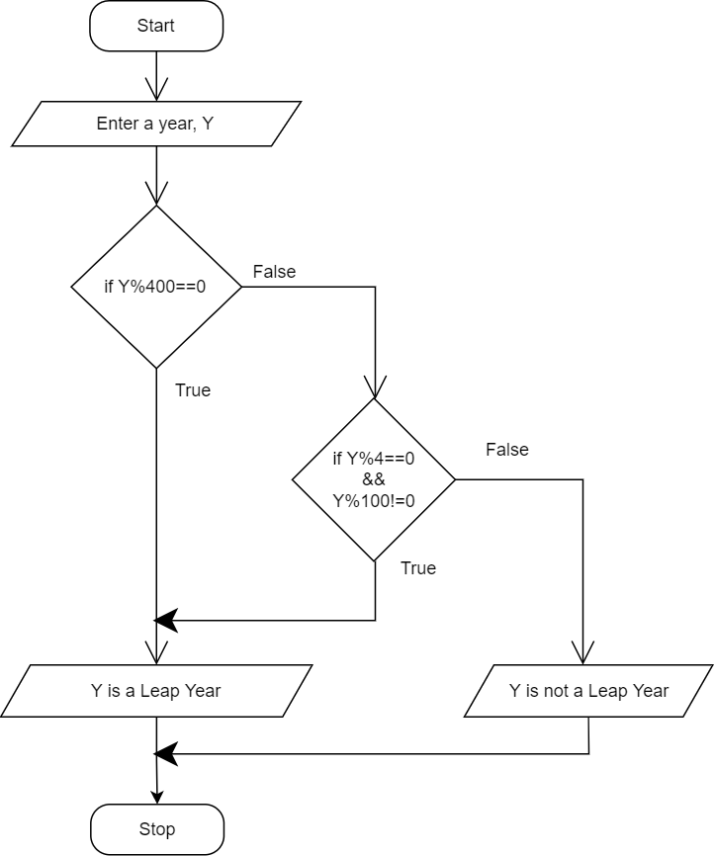

**Q.11 Find the smallest of 3 numbers.**

1. Enter 3 numbers a,b,c.

2. Check between a and b which is smaller.

3. Check between c and whichever is small between a and b.

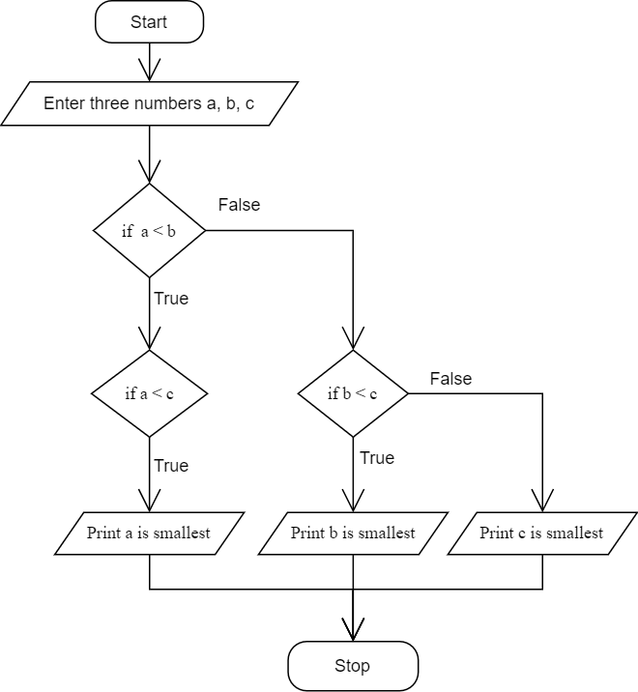

**Q.19 To print the following series Even number series 2 4 6 8 10 12 ………**

1. Initialise i, i=2

2. Print i with for loop by adding 2 in each iteration.

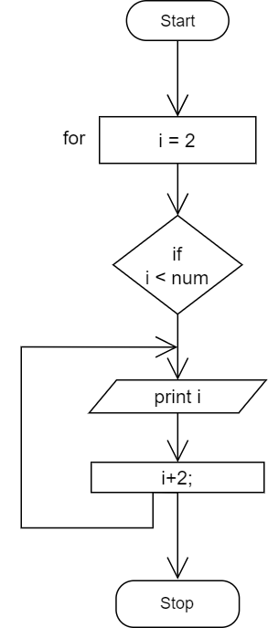

**Q.20 To print the following series odd number series 1 3 5 7 9………….**

1. Initialise i, i=1

2. Print i with for loop by adding 2 in each iteration.

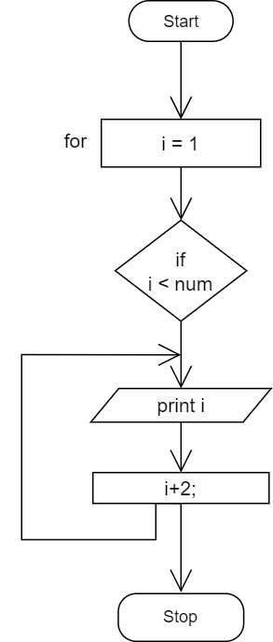

**Q.14 To find GCD of two numbers.**

1. Enter two numbers.

2. divide the numbers by i which must be less than numbers.

3. if both numbers are divisible by i, then it is their GCD (Greatest common divisor) .

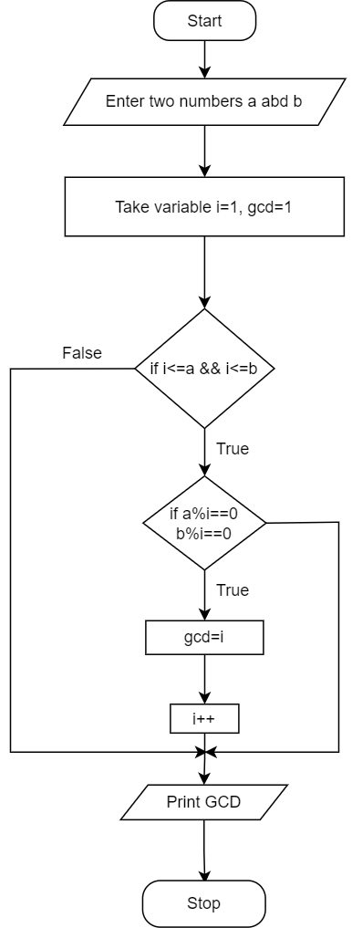

**Q. 15 To find LCM of two numbers.**

1. Initialize two variables for num1and num2
2. Find and store the maximum of num1 and num2 to a separate variable, ‘max’.
3. If max is divisible by num1and num2 max is the LCM, hence print it.
4. If not divisible then increment max by 1, and go to step 3 until a number has been printed.

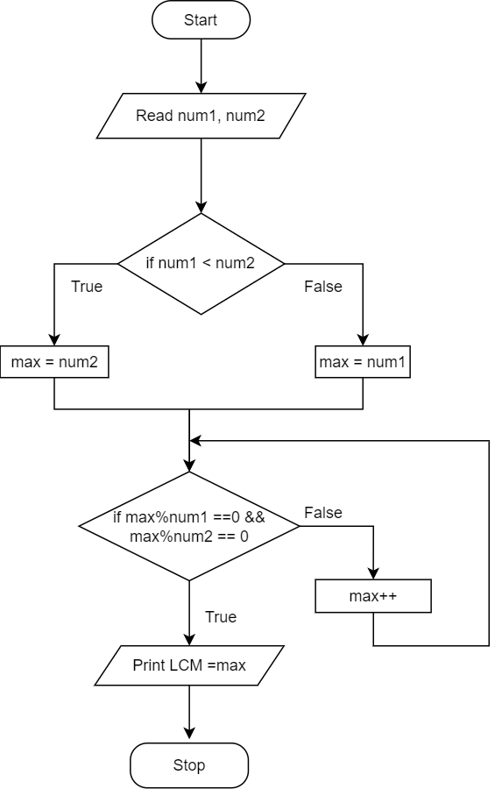

**Q.9 Print all factors of number**

1. Enter a number
2. Take variable i=1.
3. In for loop divide number i, if it is divisible by i print it or else increment i by 1.
4. Repeat the same.

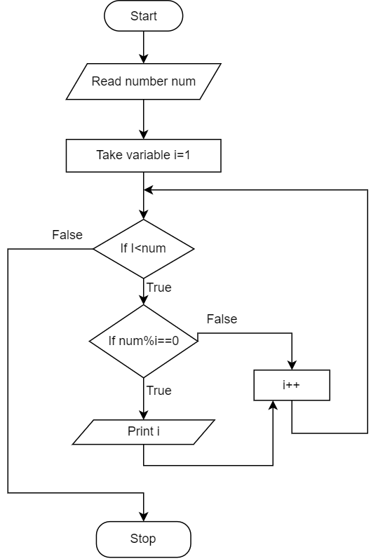

**Q.5 To check whether the given number is positive or negative.**

1. Enter a number, num.
2. If num is greater than 0, it is a positive number else it is negative number.
3. Print the result

